 | Tel: Home +2 0882338729 -Mobile +2 01001737897  Email: Mohamed.mahran@rocketmail.com
South Egypt Cancer Institute
Mohamed Hesein Mahran Shehata

Personal data  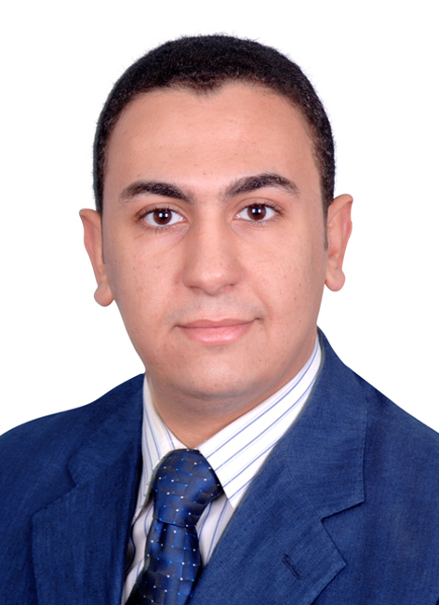 | First name : Mohamed  Middle names : Hesein  Last name (Family or Surname):Mahran  Tel: Home : +2 0882338729  Hospital : +2 0882421226  Mobile : +2 01001737897  Email : Mohamed.mahran@rocketmail.com  Date of birth : 24, Nov, 1984.  Marital status : married.  Nationality : Egyptian.  Address : Egypt, Assiut ,  Correspondence: Egypt, Assiut, South Egypt Cancer Institute (SECI), Department of surgical oncology.  Current hospital: Department of surgical oncology, South Egypt Cancer Institute (SECI), Assiut University, Assiut, Egypt.  Non-medical interests: Sports (football,swimming) and reading novels.  Languages : Arabic English.and little German
Current position | Assistant lecturer of Surgical Oncology, South Egypt Cancer Institute (SECI), Assiut University, Assiut, Egypt .
Positions held | House officer: Assiut University Hospital (1/3/2008-28/2/2009).  Resident (Surgical Oncology): Assiut University Hospital (1/3/2009-28/2/2012).
Qualifications | High school diploma (basic education): Dar Heraa High School, Assiut, Egypt (1998-2001).  MB.Bch: Faculty of medicine, Assiut University (9/9/2007) (Excelent with honor). [1]M.Sc. in Surgical Oncology: South Egypt Cancer Institute.  [2]Other certificates: International TOEFL (score: 260/300),  [3]Member of Egyptian Surgical Oncology Association.
Professional licensure | Egyptian ministry of health full registration no.: 178146
Clinical Experience | During my work as a house officer, as a resident and as an assistant lecturer, I gained experience in the following activities: (High experience in all the following:)  • Minor surgical maneuvers  • Out-patient clinical management  • In-patient clinical management  • Emergency surgery, in the emergency surgery unit of my department concerned with the reception of cases like intestinal obstruction and acute abdomen and in addition, in the trauma unit in my university hospital,  • Certain operations like the various types of open cholecystectomies, thyroidectomies, mastectomies, splenectomy, pancreatectomies, gastrectomies, and hernioplasties, operations on the liver (open liver biopsy for liver tumors, management of liver trauma with its different degrees, and assistance in liver resections including major resections) .  • Open colorectal surgery (various types of colectomies, anterior resection, abdominoperineal resection) .  •Certain surgical oncology operation , assistance in whipple operation . radical hysterctomu and radical cystectomy of bladder cancer and pelvic lymph node dissection , radical head and neck surgery neck dissection .  •Endoscopy:  •Upper and lower GI endoscopy.currently training.  •Ultrasonography: Currently, I’m training on abdominal US.
Graduate, post graduate training, courses and conferences attended | 2001-2007: Graduate studies; Faculty of medicine, Assiut University.  2008-2009: House officer; Assiut University Hospital.  2009-2012: Resident; General Surgery dept., Assiut University Hospital.  2012 : 25-28 Jan; Attendance and participation of 10th Egyptian Hepato-  pancreato-biliary society conference in Aswan, Egypt.  2015: I had a training for 6 months in japan Nagoya on laparscopic techniques(Tapp hernioplasty, appendectomy, cholecystectomy and gastrectomy)hand on training.
Teaching activities | Supervising house officers since March, 2009.  Supervising the work of residents since December, 2010.  Involved in undergraduate student teaching since March, 2012.
Research activities | Conventional cystoscopy and flursence cystoscopy in early detection of cancer bladder.
Referees and references  FACULITY AND LEADERSHIP TRAINING COURSE: | [1] Assiut University was inaugurated in 1957 to encourage research, education and community services in Upper Egypt. It is located in Assiut City which is 375 Km south of Cairo, the capital. The university comprises sixteen faculties and two higher institutions. PO Code No. 71515, Egypt. http://www.aun.edu.eg  [2] Assiut University Hospital is one of the biggest University Hospitals in Egypt. It is the core referral center for the whole Upper Egypt that serves about twenty million people. The hospital contains 2027 beds, including 94 ICU beds, and 46 operative theaters in which 240 operations are performed daily. 1478 medical and 6428 paramedical staff serves in this hospital. 3000 patients visit the outpatient clinics and 1000 are received in the emergency departments daily. The department of General Surgery contains 420 beds, including 98 beds in six specialized units: Laparoscopic Surgery unit, Pediatrics Surgery unit, Facio-maxillary surgery unit, Emergency Surgery unit, Endoscopy unit (including ERCP). http://www.aun.edu.eg/fac_med/medicin/Hospital2.htm  [3] Egyptian Hepato-pancreato-biliary (EHPB) society. http://www.ehpb.org.eg  New Trends in Teaching 20 H  Effective Teaching Skills 20 H  Communication Skills 20 H  Teaching with Technology 15 H  Legal Affairs 15 H  Research Methodology 20 H  Student Evaluation 15 H  Infection Control 15 H

